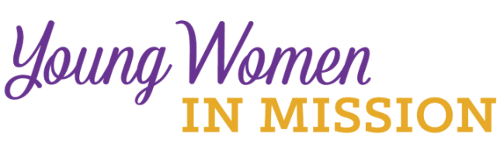
Young Woman Representative Application
LWML English District Convention April 29 – May 1, 2022 Date: ____________

Convention Location: Hilton Garden Inn Pittsburgh/Southpointe,
1000 Corporate Drive, Canonsburg, PA
Name_____________________________________ Age ______________
Address _____________________________________________________
City _____________________________ State _________ Zip ___________
Occupation ____________________________________________________
Home Congregation ______________________________________________
Phone _______________________ Email _________________________
Please answer the following questions. Use a separate sheet of paper if needed. Return the completed form to your district president.
1) The LWML motto is “Serve the Lord with Gladness” (Psalm 100:2). How do you do this in your life?
2) What groups and activities are you involved in or have you been involved in at your church?
3) What do you know about the LWML? Have you been involved at any level?

4) Why do you desire to be a Young Woman Representative for the zone?
5) What do you feel your special interests, talents, and gifts are?
6) Will you commit to serve in some capacity in your society, zone or district after the convention?

7) Your zone is making a financial commitment to send you to the LWML English District convention. It will be an exciting and spiritually inspiring event with very little free time. You are expected to participate in the full scope of the convention. Are you able to do so?

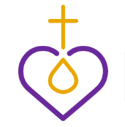
Please ask someone who knows you well, perhaps the person who encouraged you to apply, to answer the following question, “Why do you feel this woman would make a good LWML Young Woman Representative?”

Ask this person to answer on a separate sheet of paper and include their name and relationship to you. Attach their sheet to your application form.

