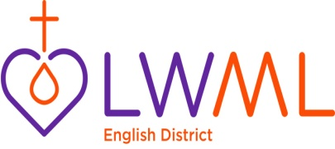
August 2020

My predecessor, Ruth Crowl, wrote, “Should you be asked to join a board, it means there is something in and about you that others have noticed. Always remember – God does not call the equipped, He equips those called.” Well, I have been asked, in the past, but always felt that the demands of motherhood were too much to add another title. Now that my children are adults, I was asked again and this time I felt like it was my time. Well, maybe not my time but God’s time.
Our LWML English District President, Darlene Keca, wrote, “Take a step in faith by doing what God’s nudging you towards. He has a plan for you.” I am fairly sure that I’ve stepped out of my comfort zone but I’m willing to learn.
I thought I’d start out by introducing myself. I’m the mother of two – a 24 year-old son who works with computer programming and a 21 year-old daughter who is studying music composition at college in Chicago. Professionally, I’m a Teacher of the Deaf serving several school districts in Allegheny County, PA. If you would’ve told me even a few weeks before mid-March 2020 that I’d be serving my students over the internet, I would have NEVER believed you! Yet here we are. Conventions have taken place on the internet. I was voted in over the internet but as the proverb goes: Where there’s a will there’s a way. God’s people will find a way to praise and serve – even if it is from home. In my case, I set up my virtual classroom with a projection screen covered by a dark blue sheet. This way, when I wear a dark top, my hands can be more easily seen when I sign to my students. I’ve also used the same set up for our online church council meetings. As I played around with the settings, I learned that I can put a picture behind me! Some of my favorites are scenery pictures from our cabin in Canada. Since I’ve started my new position with LWML English District, I’ve looked around on the LWML websites. At https://www.lwml.org/posts/free-resources/lwml-themed-digital-backgrounds I found pictures that you can download and put behind you when you are online. They are beautiful! Take a look yourself. Browse around – you never know what you’ll find.
Oh, one more thing about me – my favorite color is purple. It is as if I was made for LWML.
God’s blessings to you,
Barbara Taylor,
LWML English District
Vice President of Christian Life/Human Care

